Universal Gravitation
Student’s Name
Institutional Affiliation
Date

Universal Gravitation
Open the simulation:
https://phet.colorado.edu/sims/html/gravity-force-lab-basics/latest/gravity-force-lab-basics_en.html
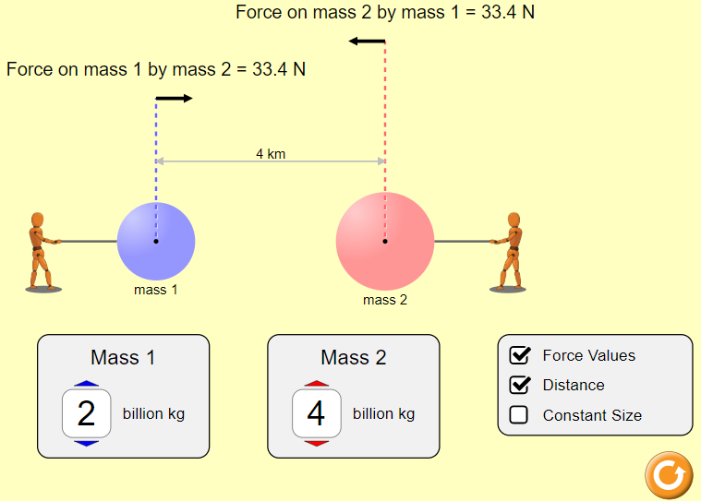
Familiarize yourself with the simulation. Play around with the settings, change the magnitude of the masses, the distance between the masses, and observe how the magnitude of the force change. When you are finished testing all the settings, click on the orange reset button.
Step 1: Set Mass 1 to 1 billion kg and Mass 2 to 5 billion kg. Set the distance “r” between the charges to 5 km (by dragging one or both masses). Write down the force on mass 1 by mass 2, and the force on mass 2 by mass 1.
Force on mass 1 by mass 2 = 13.3 N
Force on mass 2 by mass 1 = 13.3N
Notice that the force of mass 1 on mass 2 is the same as that of mass 2 on mass 1. Also notice that the direction of the force in the simulation shows that the two masses attract each other.
Keeping the mas 1 fixed, increase the mass 2, and observe how the magnitude of the force between the two masses changes. Then keep the mass 2 fixed and increase the mass 1 and then decrease mass 1.
Does the force increase or decrease when one or both masses are decreased?
Your answer:
When one or both masses are decreased, the force decreases. Force is proportional to masses, and when either of the mass is changed, the force changes proportionally (Mi & Kang, 2020).
Step 2: Set Mass 1 to 1 billion kg and Mass 2 to 3 billion kg. Set the distance “r” between the charges to 2 km. Record the magnitude of masses in kg (remember that 1 billion kg = 10⁹ kg), the distance between them in meters (remember that 1 km = 1000 m, and the magnitude of the force in the table on the next page.
Step 3: Keeping the masses fixed Mass 1 = 1 billion kg and Mass 2 = 3 billion kg, change the distance between them to 3 km or 3000 m, record the force again in the table, along with the distance and magnitude of masses.
Step 4: Repeat step 2 for distances 4 km, 5km, 6 km, 7 km, 8 km, and 9 km. Record all the data in the table.
Mass 1  m₁ (kg) | Mass 2  m₂ (kg) | r  (m) | Force on m₁ by m₂  (N)
1 x 10⁹ | 3 x 10⁹ | 2000 | 50.1
1 x 10⁹ | 3 x 10⁹ | 3000 | 22.2
1 x 10⁹ | 3 x 10⁹ | 4000 | 12.5
1 x 10⁹ | 3 x 10⁹ | 5000 | 8.0
1 x 10⁹ | 3 x 10⁹ | 6000 | 5.6
1 x 10⁹ | 3 x 10⁹ | 7000 | 4.1
1 x 10⁹ | 3 x 10⁹ | 8000 | 3.1
1 x 10⁹ | 3 x 10⁹ | 9000 | 2.5

Does the force increase or decrease as the distance between the two masses is increased?
Your answer:
When the two masses exert a large distance between them, the force acting decreases. The force among the two objects is strengthened by the smaller distance between the two masses (Mi & Kang, 2020). Thus increasing the distance will keep the force decreasing.
Make a prediction: Do you think that the force drops as 1/r or as 1/r²?
Your answer:
In either 1/r or as 1/r², the force decreases. Changes of force decrease in intensity as 1/r or as 1/r². This is because the same force requires to act through a larger spherical area. The drop of the force is precisely related to the inverse square of the distance.
Step 5: Go to: https://mycurvefit.com/
On the top you will see plot, and below it you will see a data table. Click on the “Clear” link to the right of the data table to clear the data.
Step 6: Use your mouse to select only the data in the last two columns of your table above (starting from 2000, not including the heading row that has r and Force on q₁ by q₂), copy this data. Paste this data into the data table by clicking in the table on your mycurvefit.com browser and pressing ctrl+v on the keyboard.
It will ask you: Is your data arranged by rows or by columns? Select “By Row” and click “Next”.
Then it will ask you: Which columns contains the X-axis data? Click on the left column and click “Next”.
Finally, it will ask you: Is this correct (with all the data displayed”? Click “Apply”.
Now you should see the graph created from your data.
Step 7: Click on the link “Fit Method” under the graph, from the drop down menu click on “Nonlinear” and then on “Power: y = ax^{b}”.
Now click anywhere outside the “Fit Method” menu. You will notice the fit parameters under your graph. The computer has fit your data to the function and : y = ax^{b} providing you all the fit parameters, like R²:1, aR²:1 etc.
Take a picture of your graph (or a screenshot) along with the fit parameters and paste it in the space below.
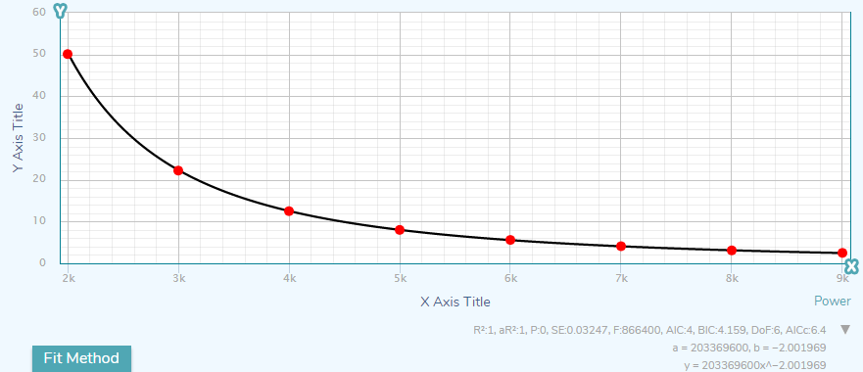
At this point we are only interested in the fit function that is given on the third line under the graph. It should be something like y = 187634x^-1.56. Write down this function in the space below:
y = 203369600 x^-2.001969
What is the coefficient (experiment): a = 203369600
What is the power (experiment): b = -2.001969
Based on the results above, was your prediction in Step 4 correct?
Your answer:
The prediction was incorrect. Because as r reduces the, force strengthens. The distance between the masses will shorten, and the proportional forces acting will remain high.
Step 8: In 1687, English physicist Sir Isaac Newton discovered that the force between two point like objects with masses m₁ and m₂ separated by a distance r is given by:
$$F=G\frac{m_{1}m_{2}}{r^{2}}$$
We call it Newton’s law of universal gravitation.
In our fit above to the data that we collected; x represents r the distance. So, if you compare the fit function above to the Newton’s law of universal gravitation, you should expect that:
The coefficient: a = $Gm_{1}m_{2}$
And the power (theory): b = $-2.0$
Use the experimental value from your fit above and the actual value from theory to calculate the percent error. Show all your work below.
$$\% error= \left|\frac{b\left(theory\right)-b(experiment)}{b(theory)}\right| x 100$$
$$\% error= \left|\frac{(-2)-(-2.001969)}{-2}\right| x 100$$
$\% error=$ __- 0.09845%____________
Step 9: Now since: a = $Gm_{1}m_{2}$ and you know the value of coefficient a from the fit above, and the charges are fixed throughout the experiment, i.e. m₁ = 1 x 10⁹ kg, and m₂ = 3 x 10⁹ kg, use all these values to find the value of the universal constant G, using the equation below. Show all your work:
a = $Gm_{1}m_{2}$
203369600=Gx1 x 10⁹ kg x 3 x 10⁹ kg
G=203369600/ (3 x 10¹⁸) = 6.779 x 10⁻¹¹
G (experiment) = 6.779 x 10⁻¹¹
Actual value of $G$is: G (actual) = 6.674 x 10⁻¹¹
Step 10: Use the experimental value from your fit above and the actual value from theory to calculate the percent error. Show all your work below.
$$\% error= \left|\frac{G\left(actual\right)-G(experiment)}{G(atual)}\right| x 100$$
$$\% error= \left|\frac{(6.674 x 10-11)-(6.779 x 10-11)}{6.674 x 10-11 }\right| x 100$$
$\% error=$ __-1.573%________

Reference
Mi, X., & Kang, B. (2020). On the belief universal gravitation (BUG). Computers & Industrial Engineering, 106685.

